DAA LAB ACTIVITY – 5
Name: RATHISH P P
Roll no: CH.SC.U4CSE24238

Merge sort:
Code:
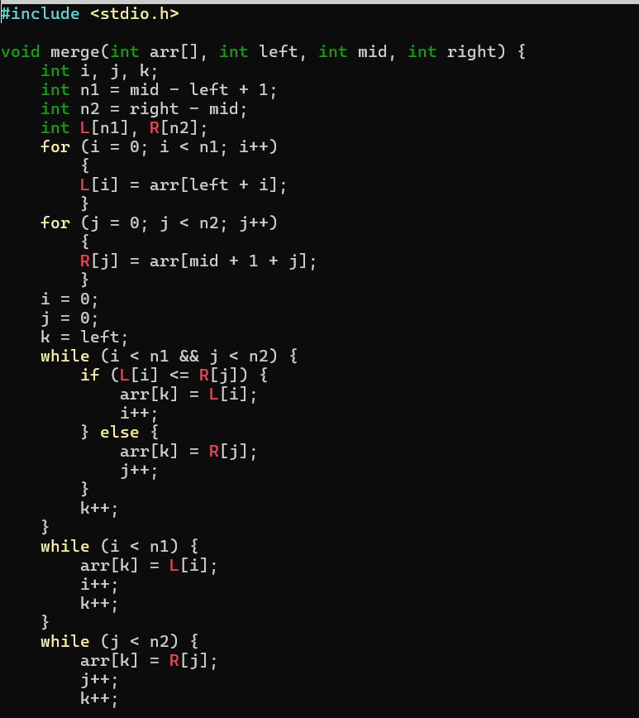
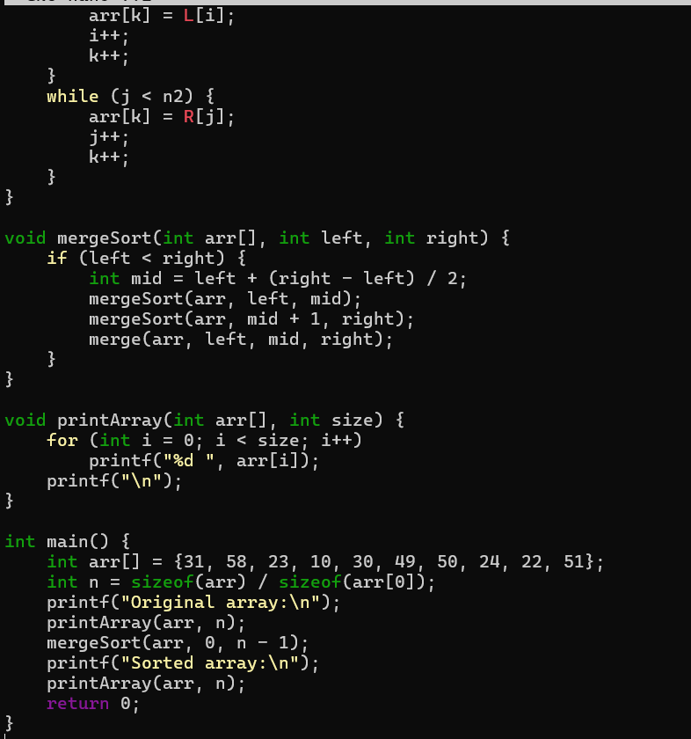
Output:
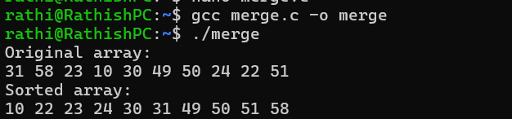

Quick sort:
Code:
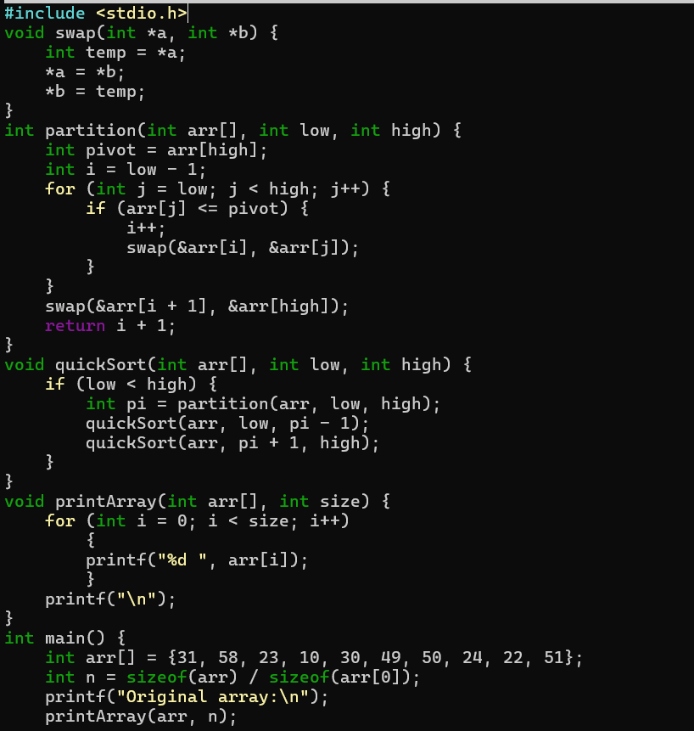
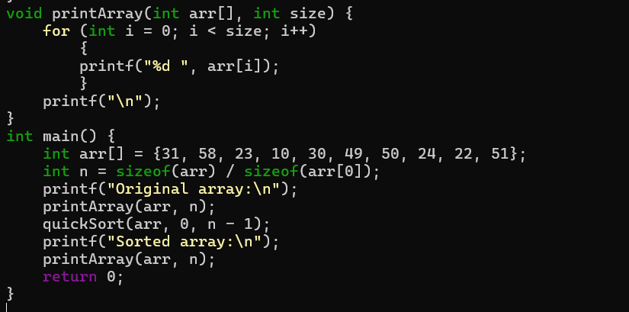Output:
